OBJECTIVE QUESTIONS

1.What is the total number of attributes in the customer table?
Query:
SELECT COUNT(*) as num_of_columns
FROM INFORMATION_SCHEMA.COLUMNS
WHERE TABLE_SCHEMA = 'ecommerce_project'
AND TABLE_NAME = 'customers';
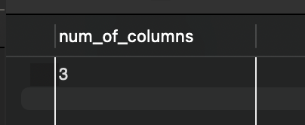

2. How will you get the “Customer’s” ages in the “Order” tables according to customer IDs?
We’ll join the tables.
Query:
select o.*, c.CustomerAge
from orders o
join customers c on o.CustomerID=c.CustomerID;

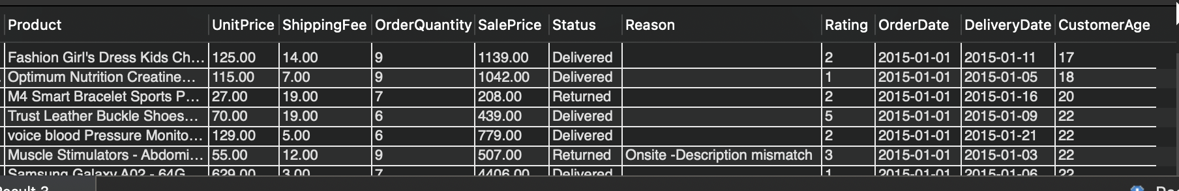

3. In analyzing the dataset with Power BI, ensure data cleaning to address inconsistencies and missing values before further analysis.
Data cleaning and validation were performed in Power BI (Power Query) before building the data model. The following steps were taken:
- Missing Value Audit: Checked for null and blank values across important columns such as OrderID, ProductCategory, CustomerID, Rating, UnitPrice, and Date fields. Missing categorical values were corrected using related column logic (e.g., mapping subcategory to its correct category).
- Blank Value Handling: Identified empty strings in text columns and standardized them to maintain consistency in reporting.
- Range Validation: Verified minimum and maximum values for numeric fields (UnitPrice, SalePrice, OrderQuantity, ShippingFee, Rating) to detect outliers or abnormal values.
- Revenue Logic Consistency: Validated that revenue calculations were consistent (SalePrice = UnitPrice × Quantity + ShippingFee).
- Date Validation: Ensured correct date formats and verified that DeliveryDate was not earlier than OrderDate.
- Illogical Value Check: Checked for invalid entries such as negative prices or zero quantities.
- Referential Integrity: Confirmed that all CustomerIDs in the Orders table existed in the Customers table before establishing relationships.
These steps ensured clean, consistent, and reliable data before proceeding with further analysis and dashboard development.

4. How can we calculate the total revenue generated by all the sales?
Query:
select sum(SalePrice) as total_revenue
from orders;
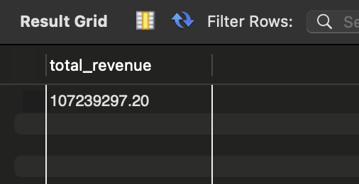

5. What is the total number of unique customers who made purchases each year? Is there any increase in the number over the years?
Query:
select year(OrderDate) as Purchase_year, count(distinct CustomerID) as unique_customers,
count(distinct CustomerID)-lag(count(distinct CustomerID)) over(order by year(OrderDate) asc) as Difference,
round((count(distinct CustomerID)-lag(count(distinct CustomerID)) over(order by year(OrderDate) asc))*100.0/lag(count(distinct CustomerID)) over(order by year(OrderDate) asc),2) as YoY_growth_percentage

from orders
group by year(OrderDate);

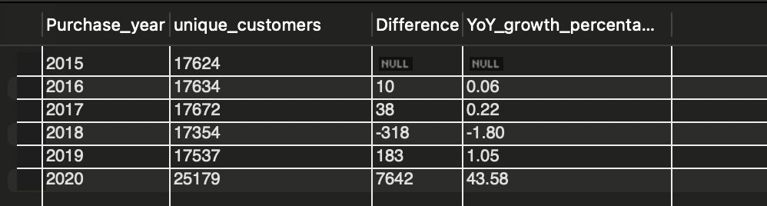

6. How can we determine the total number of unique products available in the company?
Query:
select count(distinct Product) as Unique_products from orders;
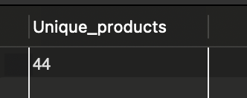

7. What is the average number of days it takes for products to be delivered, get the metric for only the delivered orders.
Query:
select avg(Datediff(DeliveryDate,OrderDate)) as avg_days
from orders
where Status='Delivered';
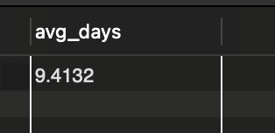

8. Which products, categories, and subcategories are the most popular?
Query:
with cte as(
select Product, sum(OrderQuantity) as Qty_ordered, rank() over(order by sum(OrderQuantity) desc) as rnk
from orders
group by Product
)
select *
from cte
where rnk=1;
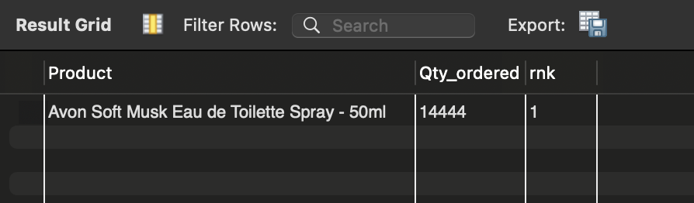

-- Similarly for categories and Subcategories
with cte as(
select ProductCategory, sum(OrderQuantity) as Qty_ordered, rank() over(order by sum(OrderQuantity) desc) as rnk
from orders
group by ProductCategory
)
select *
from cte
where rnk=1;
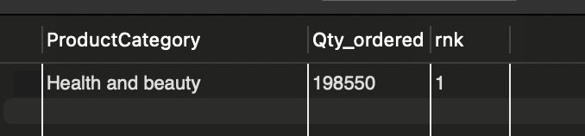

with cte as(
select SubCategory, sum(OrderQuantity) as Qty_ordered, rank() over(order by sum(OrderQuantity) desc) as rnk
from orders
group by SubCategory
)
select *
from cte
where rnk=1;
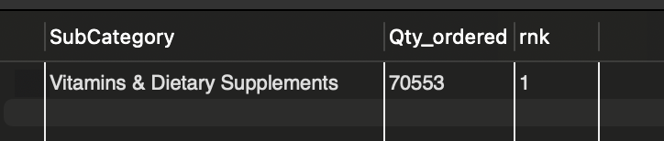

9. Which products have seen an increase or decrease in sales over the year?
with cte as(
select Product, year(OrderDate) as order_year, sum(SalePrice) as revenue
from orders
group by Product, year(OrderDate)
),
cte2 as(
select *,
revenue- lag(revenue) over(partition by Product order by order_year asc) as YoY_difference,
case
when revenue- lag(revenue) over(partition by Product order by order_year asc) <0 then 'Decrease'
when revenue- lag(revenue) over(partition by Product order by order_year asc) =0 then 'Same'
when revenue- lag(revenue) over(partition by Product order by order_year asc) >0 then 'Increase'
else null
end as YoY_Trend,
row_number() over(partition by Product order by order_year asc) as rn

from cte
order by Product, order_year asc)

select *,
case
when (select revenue from cte2 where Product=c.Product and rn= (select max(rn) from cte2 where Product=c.Product)) < (select revenue from cte2 where Product=c.Product and rn=1) then 'Net Decrease'
when (select revenue from cte2 where Product=c.Product and rn= (select max(rn) from cte2 where Product=c.Product)) = (select revenue from cte2 where Product=c.Product and rn=1) then 'Net Neutral'
when (select revenue from cte2 where Product=c.Product and rn= (select max(rn) from cte2 where Product=c.Product)) > (select revenue from cte2 where Product=c.Product and rn=1) then 'Net Increase'
end as Net_Change
from cte2 c;
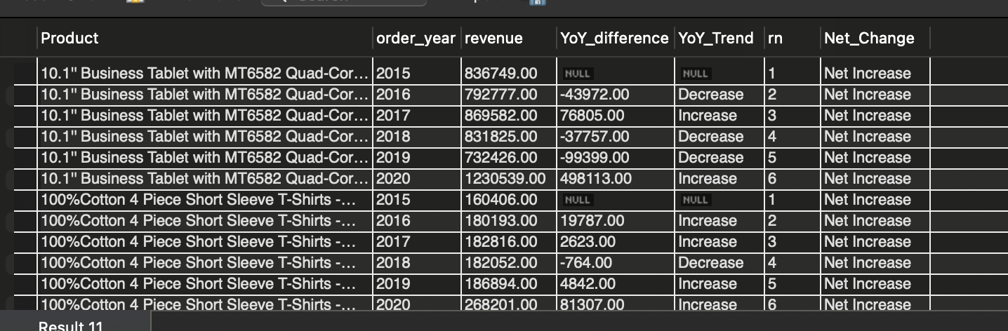

10. While modelling the data relationships, what will be the type of relationship between the customer ID of Orders and customer tables?
The relationship between CustomerID in the Customers table and Customer_ID in the Orders table is a One-to-Many relationship, where each customer can place multiple orders.

11. How have you handled the null values in the data?
First, I performed a combined null check across all columns of the orders table (and similarly for the customers table) to identify missing values.
- I also checked for empty strings separately in string-type columns, since empty values are not technically NULL but still represent missing data.
- During this process, I identified one record where the ProductCategory field was blank.
- To resolve this, I examined the corresponding SubCategory for that row and verified which product category it logically belonged to.
- Based on this validation, I updated the blank ProductCategory with the correct category derived from the subcategory.
- This approach ensured data consistency while avoiding incorrect assumptions during data cleaning.

12. Were there any data format issues in the data, and if there were/are how you would handle them?
Yes, there were data format issues related to date columns. The OrderDate and DeliveryDate fields were stored as string (text) values instead of proper DATE format. To resolve this, I converted them into DATE datatype using appropriate date conversion functions.
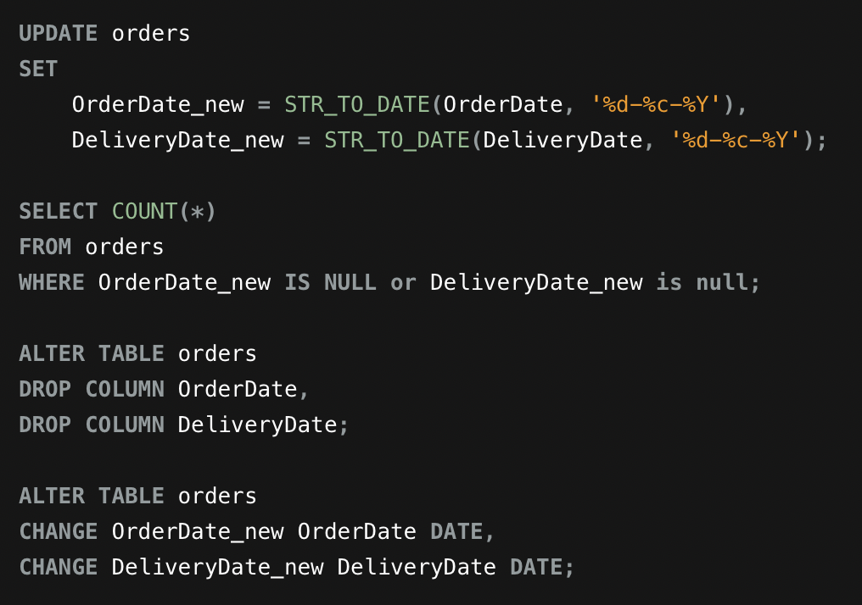

After conversion, I verified that no records failed during transformation by checking for null values in the new date columns. Once validated, I removed the old text columns and retained the correctly formatted date columns. This ensured accurate date calculations for wait time, recency, and time intelligence analysis.

13. When we add a column in Power Query what’s the code that comes in M language in the formula bar? What do you know about M-query?
When we add a column in Power Query, Power BI automatically generates M-code using functions such as Table.AddColumn(). This function defines the source table, the new column name, and the logic used to compute the column. For example, a custom column typically appears as:
= Table.AddColumn(Source, "NewColumn", each [Column1] * [Column2]).
M-Query (Power Query M language) is a functional, case-sensitive language used for data transformation and data preparation before loading data into the model. It is primarily used for tasks like filtering rows, changing data types, handling nulls, merging tables, and creating custom columns. Unlike DAX, which works on loaded data in the model, M-Query operates at the data extraction and transformation stage (ETL layer).

14. Identify the top 5 most valuable customers using a composite score that combines three key metrics: (SQL)
  - Total Revenue (50% weight): The total amount of money spent by the customer.
  - Order Frequency (30% weight): The number of orders placed by the customer, indicating their loyalty and engagement.
  - Average Order Value (20% weight): The average value of each order placed by the customer, reflecting the typical transaction size.

Query:
with customer_metrics as(
select CustomerID, round(sum(SalePrice),2) as total_revenue, count(distinct OrderID) as frequency, round(avg(SalePrice),2) as avg_order_value
from orders
where Status= 'Delivered'
group by CustomerID
),
normalized as(
SELECT *,
PERCENT_RANK() OVER (ORDER BY total_revenue) AS revenue_score,
PERCENT_RANK() OVER (ORDER BY frequency) AS frequency_score,
PERCENT_RANK() OVER (ORDER BY avg_order_value) AS aov_score
FROM customer_metrics
)
SELECT
CustomerID,
total_revenue,
frequency,
avg_order_value,
ROUND(
0.5 * revenue_score +
0.3 * frequency_score +
0.2 * aov_score
, 4) AS composite_score
FROM normalized
ORDER BY composite_score DESC
LIMIT 5;
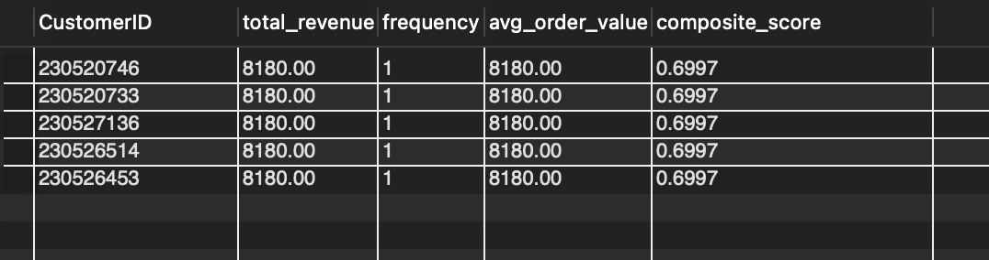

15. Calculate the month-over-month growth rate in total revenue across the entire dataset. (SQL)
Query:
with cte as(
select DATE_FORMAT(OrderDate, '%Y-%m') as Year_Month_period, sum(SalePrice) as Total_Revenue
from orders o
group by DATE_FORMAT(OrderDate, '%Y-%m')
)
select * ,
round(((Total_Revenue-lag(Total_Revenue) over(order by Year_Month_period))*100.0/lag(Total_Revenue) over(order by Year_Month_period)),2) as MoM_Growth_rate
from cte ;

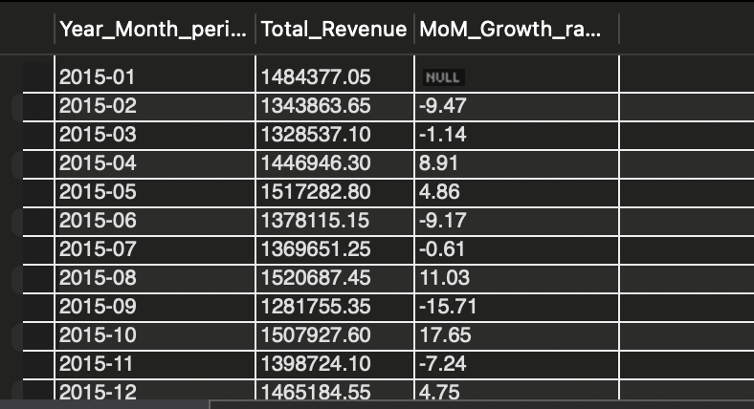

16. Calculate the rolling 3-month average revenue for each product category. (SQL)
Query:
with cte as(
select ProductCategory, date_format(OrderDate,'%Y-%m') as Year_month_period, sum(SalePrice) as Revenue
from orders
where Status= 'Delivered'
group by ProductCategory, date_format(OrderDate,'%Y-%m')
)

select *,
round(avg(Revenue) over(partition by ProductCategory order by Year_month_period rows between 2 preceding and current row),2) as three_month_rolling_avg
from cte;

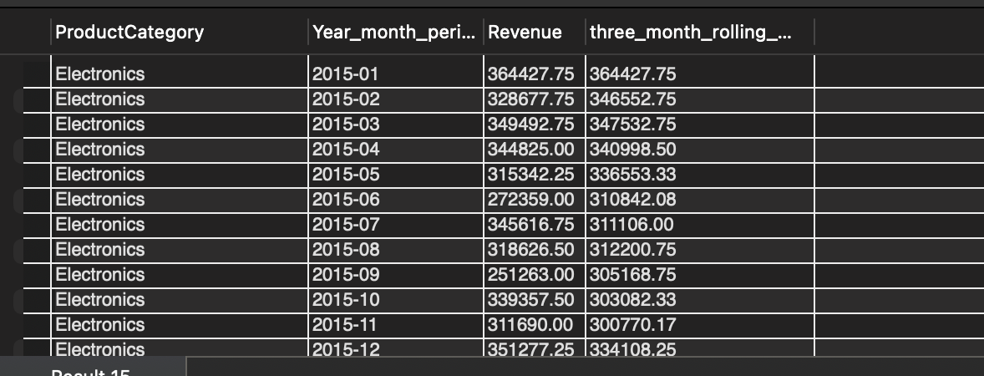

17. Update the orders table to apply a 15% discount on the `Sale Price` for orders placed by customers who have made at least 10 orders. (SQL)
We can do this by using UPDATE, but we are Not using Update delibrately, because we dont want to change the actual data for the sake of this question
SELECT *,
CASE
WHEN CustomerID IN (SELECT CustomerID FROM orders GROUP BY CustomerID HAVING COUNT(DISTINCT OrderID) >= 10) THEN ROUND(SalePrice * 0.85, 2)
ELSE 'No discount'
END AS discounted_price
FROM orders;
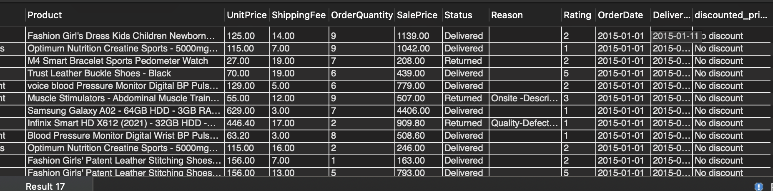

18. Calculate the average number of days between consecutive orders for customers who have placed at least five orders. (SQL)
Query used:
select CustomerID
from orders
group by CustomerID
having count(*)>=5;
No such customers were found, who have atleast five orders

19. Identify customers who have generated revenue that is more than 30% higher than the average revenue per customer. (SQL)
Query used:
with total as(
select CustomerID, sum(SalePrice) as total_rev_from_customer
from orders
group by CustomerID
),
average as(
select avg(total_rev_from_customer) as avg_rev_per_customer
from total
)
select CustomerID
from total
where total_rev_from_customer> 1.3*(select avg_rev_per_customer from average);
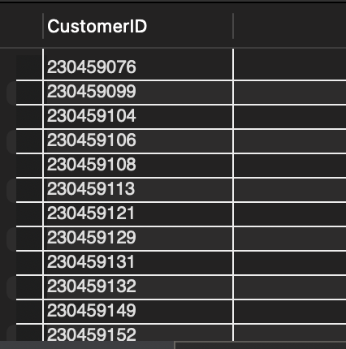

20. Determine the top 3 product categories that have shown the highest increase in sales over the past year compared to the previous year. (SQL)
Query used:
with cte as(
select ProductCategory,
sum(case when year(OrderDate)=2019 then SalePrice end) as Rev_2019,
sum(case when year(OrderDate)=2020 then SalePrice end) as Rev_2020
from orders
where Status='Delivered'
group by ProductCategory
)

select *, Rev_2020-Rev_2019 as Change_in_Rev
from cte
order by Change_in_Rev desc
limit 3;
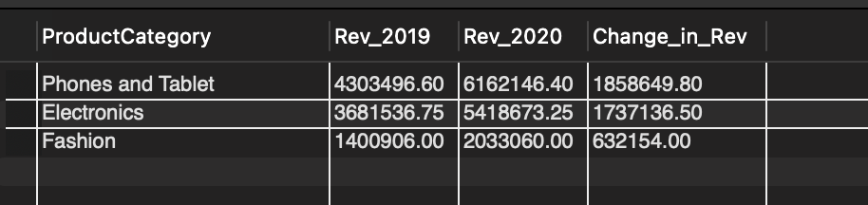

SUBJECTIVE QUESTIONS
Q1) Explain the revenue breakdown by year and by product. Evaluate how different products contribute to annual revenue and suggest ways to increase the sales of low-selling items.

Objective
To analyze the yearly revenue trend, examine product-level contribution to annual revenue, and identify strategies to improve the performance of low-selling products.

Approach
The analysis was performed in the following steps:
- Created a line chart to evaluate revenue trends by year.
- Built a matrix (Year × Product) to examine product-level revenue distribution by year.
- Calculated Product Contribution (%) and Product Rank by Year to evaluate relative performance.
- Used bar charts to compare revenue by Product Category and Product.
- Identified high-performing and low-performing products based on revenue share and ranking.

DAX Used
Total_Revenue = CALCULATE(SUM(ORDERS_CLEANED[SalePrice]),ORDERS_CLEANED[Status]="Delivered")
Product_Rev_Contribution = DIVIDE([Total_Revenue], CALCULATE([Total_Revenue],ALL(ORDERS_CLEANED[Product])))
Product_Rank_by_Year = RANKX(ALL(ORDERS_CLEANED[Product]),[Total_Revenue],,DESC,Dense)

Insights / Analysis

Revenue Breakdown by Year
- Revenue remained relatively stable between 2015–2019, averaging around 12M annually.
- 2020 shows a significant spike (~17.4M), making it the highest revenue year.
- This indicates strong growth momentum in the latest year.
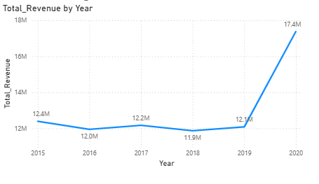

Product-Level Contribution
- The top-performing product contributes approximately 14% of annual revenue.
- The top 3 products together contribute over 30% of total yearly revenue.
- Revenue is highly concentrated among a limited number of products.
- Several lower-ranked products contribute less than 3% individually.
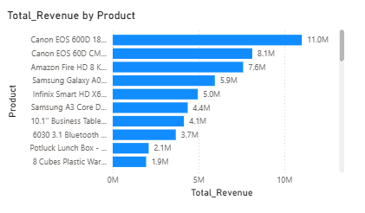
This shows a skewed revenue distribution, where a few products drive overall performance.

Category-Level Observations
- Phones & Tablets and Electronics generate the highest revenue.
- Other categories (Fashion, Health & Beauty, Home & Office) contribute comparatively lower revenue.
Revenue growth is therefore strongly dependent on specific dominant categories.

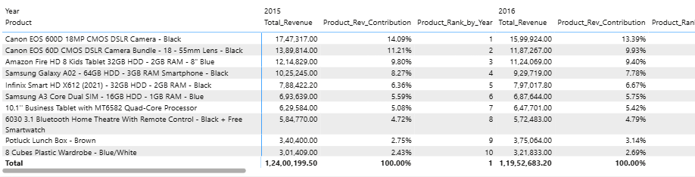

Low-Selling Products
Low-performing products are identified by:
- Low contribution percentage
- Lower ranking positions across years
- Minimal impact on total annual revenue
These products do not significantly influence overall growth.

Recommendations
- Bundle low-selling products with high-performing items to improve visibility.
- Introduce targeted discounts or seasonal offers to stimulate demand.
- Review pricing strategy for underperforming products.
- Improve product positioning and marketing visibility.
- Analyze customer ratings and returns to identify potential product issues.
- Consider phasing out consistently underperforming SKUs if necessary.

Conclusion
The revenue analysis shows steady performance from 2015–2019, followed by strong growth in 2020. Revenue is highly concentrated among a few top-performing products and dominant categories such as Phones & Tablets and Electronics.
While these products drive growth, several low-selling items contribute minimally. Strategic pricing, bundling, and promotional interventions are required to improve their performance and create a more balanced revenue distribution.

Ques2. How many products were returned? Use a DAX function to get this metric. Examine the possible reasons for returns and consider how this metric could indicate improvements in product descriptions or quality control.

Objective
To determine how many products were returned, calculate the overall return rate using DAX, analyze the primary reasons for returns, and evaluate how this metric can indicate opportunities for improving product descriptions, quality control, and operational processes.

Approach
- Created a DAX measure to calculate the total number of returned products.
- Calculated the overall return rate as a percentage of total orders.
- Analyzed returns by:
  - Return reason
  - Product category
- Interpreted the patterns to identify key operational and quality-related issues.
- Developed actionable recommendations based on the findings.

DAX Used
Returned_Products = CALCULATE(COUNT(ORDERS_CLEANED[OrderID]),ORDERS_CLEANED[Status]="Returned")

Return_Rate = DIVIDE(CALCULATE(COUNTA(ORDERS_CLEANED[OrderID]), ORDERS_CLEANED[Status]="Returned"), COUNT(ORDERS_CLEANED[OrderID]))

Insights / Analysis

Overall Returns
- Total Returned Products: Approximately 31,000
- Return Rate: 27.01%
This indicates that nearly one in every four orders is returned, which is relatively high and suggests operational or quality concerns that require attention.

Returns by Product Category
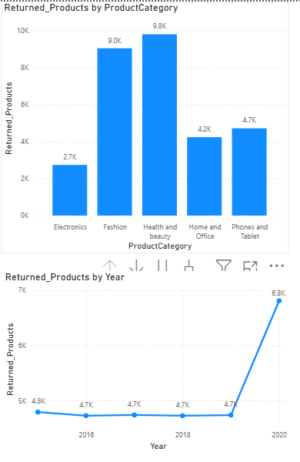
The highest return volumes were observed in:
- Health & Beauty (approximately 9.3K)
- Fashion (approximately 9.0K)
- Phones & Tablets (approximately 4.7K)
- Home & Office (approximately 4.2K)
- Electronics (approximately 2.7K)
Observation:
Fashion and Health & Beauty contribute disproportionately to total returns. These categories are often sensitive to customer expectations, sizing issues, or product performance variability, which may explain the higher return volume.

Returns by Reason
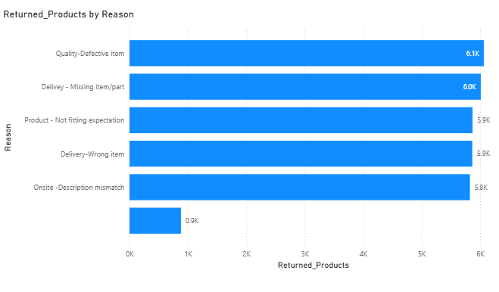
The leading reasons for returns include:
- Quality – Defective Item (approximately 6.1K)
- Delivery – Missing Item/Part (approximately 6.0K)
- Product – Not Fitting Expectation (approximately 5.9K)
- Delivery – Wrong Item (approximately 5.9K)
- Description Mismatch (approximately 0.9K)
Key observations:
- Quality-related defects are a major driver of returns.
- Logistics errors such as missing or incorrect items are equally significant.
- “Not fitting expectation” suggests potential gaps in product representation, images, specifications, or size guidance.
- Description mismatch appears relatively lower compared to operational and quality issues.

Recommendations
- Strengthen Quality Control
Implement stricter inspection processes before dispatch. Analyze defect patterns by supplier and monitor repeat-return products.
- Improve Logistics Accuracy
Introduce barcode-based verification before shipment and enhance packing accuracy to reduce missing or wrong items.
- Improve Expectation Management
Enhance product images and specifications. Provide clearer size charts, especially in the Fashion category. Incorporate customer reviews and detailed usage information.
- Category-Specific Focus
Since Fashion and Health & Beauty show the highest return volumes, conduct deeper SKU-level analysis to identify consistently problematic products and evaluate supplier performance.

Conclusion
The analysis shows a return rate of 27.01%, representing a significant operational and financial impact. The primary drivers of returns are product defects and delivery inaccuracies, followed by expectation mismatches.
By improving quality control, fulfillment processes, and product presentation, the company can reduce return rates, improve customer satisfaction, and enhance overall operational efficiency
Question 3:
Whenever a customer goes to Amazon, they’ll filter the most rated products to buy the better category. Can you verify using any visualization or table that the ratings of products impact their sales value?
Solution:

Objective
To verify whether higher-rated products generate higher sales revenue, and to determine if product ratings significantly impact sales value.

Approach
To analyze the relationship between product ratings and sales value, the following approach was used:
- Created overall revenue and rating measures without filtering by delivery status to ensure the complete dataset was analyzed.
- Built a scatter plot with:
  - X-axis: Average Rating per Product
  - Y-axis: Total Revenue per Product
  - Each point representing a product.
- Added a trend line to observe the direction and strength of the relationship.
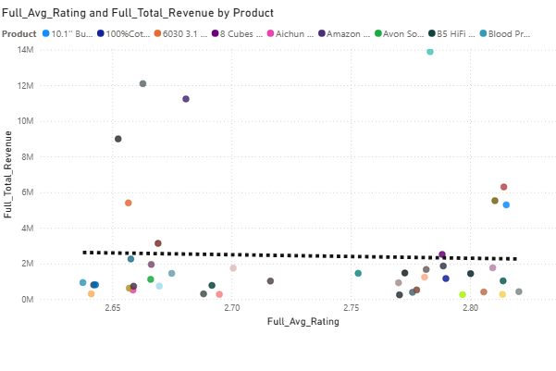
- Created a supporting table sorted by average rating (descending) to compare rating levels with corresponding revenue values.

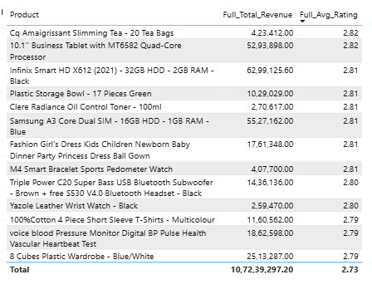
This combination allows both visual and tabular verification of whether higher ratings lead to higher sales.

DAX Used
Full_Avg_Rating = AVERAGE(ORDERS_CLEANED[Rating])
Full_Total_Revenue = SUM(ORDERS_CLEANED[SalePrice])

Insights / Analysis
1. Rating Distribution
The average ratings across products fall within a very narrow range (approximately 2.65 to 2.82). There is no large variation between highly rated and lower-rated products.
2. Scatter Plot Observation
The scatter plot shows:
- Revenue values widely distributed across similar rating levels.
- High-revenue products appearing at both mid and high rating levels.
- The trend line is nearly flat, indicating a very weak relationship between rating and revenue.
3. Table Verification
When the table is sorted in descending order of average rating:
- The highest-rated products do not consistently generate the highest revenue.
- Some products with slightly lower ratings generate significantly higher revenue.
- Revenue levels vary independently of rating levels.
4. Overall Relationship
The nearly flat trend line and narrow rating range suggest that rating does not strongly influence sales value in this dataset.

Conclusion
Based on the scatter plot, trend line, and product-level table analysis, there is no strong evidence that higher product ratings significantly impact sales revenue in this dataset.
Although customers may consider ratings while purchasing, the data suggests that other factors—such as pricing, brand recognition, category demand, or promotions—may have a stronger influence on sales performance than ratings alone.
Therefore, the assumption that customers primarily filter and purchase products based on rating is not strongly supported by the current analysis.

Ques4. Investigate how revenue distribution varies across different locations. Explore which geographical areas contribute most to sales and consider the strategic implications for regional marketing and distribution efforts. How might location-based trends inform the company's market segmentation and resource allocation approach?

Objective
To analyze how delivered revenue is distributed across different zones and locations, identify the highest contributing geographical areas, and derive strategic insights for regional marketing, market segmentation, and resource allocation.

Approach
The analysis was conducted in two stages:
- Macro-Level Analysis (Zone Level)
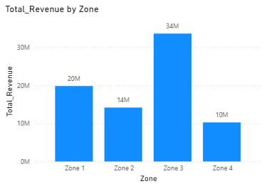
  - Examined total delivered revenue by zone.
  - Calculated revenue contribution percentage per zone.
  - Compared delivered order volume with revenue to determine whether revenue dominance was driven by volume or pricing.
  - Analyzed return rate and average order value across zones.

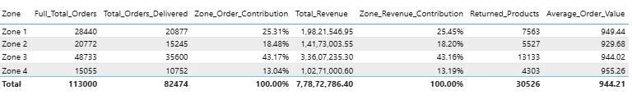

- Micro-Level Analysis (Location Level)
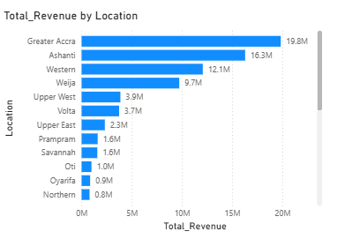
  - Ranked individual locations by delivered revenue.
  - Calculated revenue contribution percentage per location.
  - Identified high-performing and underperforming regions.
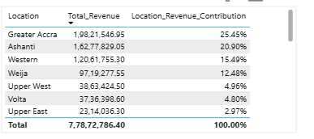

This dual-level approach enables both high-level strategic evaluation and granular geographic insight.

DAX Used
Total_Orders_Delivered = CALCULATE(COUNT(ORDERS_CLEANED[OrderID]), ORDERS_CLEANED[Status]="Delivered")
Zone_Order_Contribution = DIVIDE([Total_Orders_Delivered],CALCULATE([Total_Orders_Delivered],ALL(ORDERS_CLEANED[Zone])))
Zone_Revenue_Contribution = DIVIDE([Total_Revenue], CALCULATE([Total_Revenue],ALL(ORDERS_CLEANED[Zone])))
Average_Order_Value = CALCULATE(AVERAGE(ORDERS_CLEANED[SalePrice]), ORDERS_CLEANED[Status]="Delivered")
Location_Revenue_Contribution = DIVIDE( [Total_Revenue],CALCULATE([Total_Revenue],ALL(ORDERS_CLEANED[Location])))

Insights / Analysis

1. Revenue Distribution by Zone
Revenue is highly concentrated in specific zones:
- Zone 3 contributes approximately 43% of total delivered revenue (~34M), making it the dominant region.
- Zone 1 contributes around 25%.
- Zone 2 contributes approximately 18%.
- Zone 4 is the lowest contributor at roughly 13%.
This indicates significant geographic concentration rather than uniform distribution.

2. Volume vs Value Analysis
Zone 3 also has the highest delivered order contribution (~43%), which closely aligns with its revenue contribution.
Average Order Value across zones remains relatively consistent (around 930–955).
This indicates:
- Revenue dominance is primarily volume-driven, not price-driven.
- There is no strong premium pricing difference between zones.
- Purchasing behavior in terms of order value is fairly uniform across regions.

3. Return Rate Analysis
Return rates across zones are very similar (approximately 26–27%).
This suggests:
- No specific region is experiencing operational inefficiency.
- Product quality and fulfillment consistency appear stable across zones.
- Revenue differences are not caused by higher return losses in any particular region.

4. Location-Level Concentration
At the micro level:
- Greater Accra is the highest revenue-generating location (~19.8M).
- Ashanti follows closely (~16.3M).
- A clear long tail of smaller locations contributes marginal percentages individually.
This confirms strong geographic concentration within a few key locations.

Strategic Implications
- Resource Allocation
Since Zone 3 contributes the largest share of revenue, it should remain a priority for:
  - Marketing budget allocation
  - Inventory availability
  - Distribution optimization
- Market Segmentation
The similarity in Average Order Value suggests that purchasing power and spending patterns are relatively uniform across zones.
Segmentation should therefore focus more on volume potential rather than pricing differentiation.
- Growth Opportunities
Underperforming zones (e.g., Zone 4) may represent:
  - Untapped growth potential
  - Regions requiring targeted marketing campaigns
  - Areas where distribution expansion could increase order volume
- Operational Stability
Since return rates are consistent across zones, there is no immediate need for region-specific quality control interventions.

Conclusion
Revenue distribution across locations is highly concentrated, with Zone 3 and key locations such as Greater Accra and Ashanti contributing the majority of delivered revenue. The dominance of these regions is driven primarily by higher order volume rather than differences in pricing.
Return rates remain consistent across zones, indicating stable operational performance. These findings suggest that the company should prioritize high-volume regions for sustained investment while strategically targeting lower-performing zones for expansion and growth initiatives.
Location-based trends therefore provide clear guidance for market segmentation, targeted marketing strategies, and informed resource allocation decisions.

Ques5. Determine which month could benefit from enhanced promotional offers to boost sales. Can you suggest some targeted marketing strategies here?

Objective
To identify the month with comparatively lower sales performance and recommend targeted promotional strategies to improve revenue and customer engagement during that period.

Approach
- Aggregated sales data by Month (across all years).
- Analyzed:
  - Total Revenue
  - Total Orders Delivered
- Used a Line and Clustered Column Chart:
  - Columns → Total Orders Delivered
  - Line → Total Revenue
- Compared month-wise trends to determine:
  - Lowest revenue month
  - Whether the dip is volume-driven or pricing-driven

DAX Used
Total_Orders_Delivered = CALCULATE(COUNT(ORDERS_CLEANED[OrderID]), ORDERS_CLEANED[Status]="Delivered")

Insights / Analysis

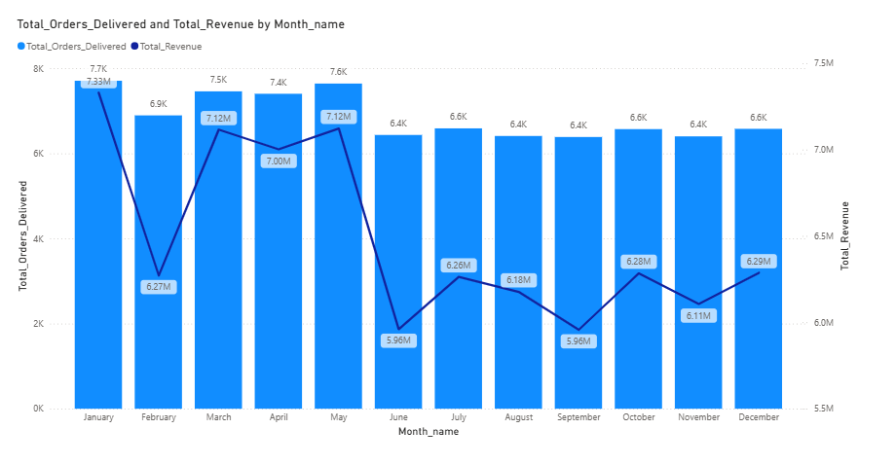

1. Revenue Trend by Month
- Highest Revenue Months:
  - January (~7.33M)
  - March (~7.12M)
  - May (~7.12M)
- Lowest Revenue Months:
  - June (~5.96M)
  - September (~5.96M)
June records the lowest revenue among all months.

2. Orders Delivered Trend
- Highest Order Volume:
  - January (~7.7K)
  - May (~7.6K)
  - March (~7.5K)
- Lowest Order Volume:
  - June (~6.4K)
  - August (~6.4K)
  - September (~6.4K)**
Orders decline during the same months where revenue drops.

3. Key Observation
Since both:
- Revenue decreases
- Orders delivered decrease
The issue is volume-driven, not pricing-driven.
This indicates reduced customer activity or engagement during June (and September), rather than a decline in average spending per order.

Recommendation

Primary Target Month:

June
(Secondary weak month: September)
Since the problem is lower customer engagement, strategies should focus on increasing traffic and purchase frequency.

Suggested Marketing Strategies:
- Mid-Year Sale Campaign
  - Limited-time discounts
  - Flash sales
  - Bundle offers
- Re-engagement Campaigns
  - Email/SMS campaigns targeting inactive customers
  - Personalized recommendations
- Seasonal Promotions
  - Summer sale (for June)
  - Back-to-school promotions (for September)
- Incentive-Based Offers
  - Free shipping
  - Cashback rewards
  - Loyalty points multipliers
- Digital Advertising Boost
  - Paid ads during low-performing months
  - Social media engagement campaigns
The goal should be to increase transaction volume rather than reduce pricing drastically.

Conclusion
Based on month-wise analysis of revenue and delivered orders, June is the month that would benefit most from enhanced promotional efforts, as it records the lowest revenue and lower order volume.
The decline appears to be driven by reduced customer activity rather than reduced spending per order. Therefore, targeted promotional campaigns focused on customer engagement and seasonal incentives can help improve sales performance during this period.

Ques6. Identify which products may require increased marketing efforts. Which items have high prices yet underperform in sales?

Objective
To identify products that are underperforming in sales and assess whether any high-priced items are generating disproportionately low revenue, thereby requiring targeted marketing interventions.

Approach
- Analyzed product-level performance using:
  - Total Revenue (Delivered orders only)
  - Average Price per product
  - Total Orders Delivered
- Created the following visuals:
  - Scatter Plot (Average Price vs Revenue, bubble size = Orders Delivered)
  - Table sorted by Average Price (Descending) to evaluate premium product performance
  - Table sorted by Total Revenue (Ascending) to identify low-performing products
- Compared price positioning with revenue performance to detect:
  - Overall weak performers
  - Premium products underperforming relative to their pricing

DAX Used
Average_Order_Value = CALCULATE(AVERAGE(ORDERS_CLEANED[SalePrice]), ORDERS_CLEANED[Status]="Delivered")
Total_Revenue = CALCULATE(SUM(ORDERS_CLEANED[SalePrice]),ORDERS_CLEANED[Status]="Delivered")

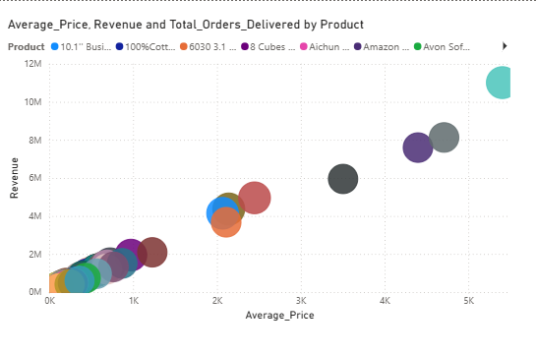

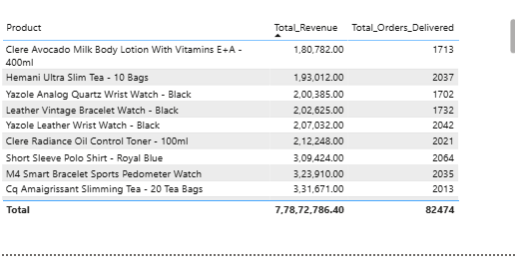

Insights / Analysis:

Overall Low-Performing Products
From the table sorted by Total Revenue (ascending), the lowest revenue-generating products include:
- Clere Avocado Milk Body Lotion
- Hemani Ultra Slim Tea
- Yazole Analog Quartz Watch
- Leather Vintage Bracelet Watch
- Clere Radiance Oil Control Toner
These products generate significantly lower revenue compared to top-performing items (which range between 8M–11M).
These items may require increased marketing attention due to:
- Lower revenue contribution
- Moderate order volume but weak overall impact

High-Priced Products Performance
From the scatter plot and price-descending table:
High-priced products such as:
- Canon EOS DSLR Camera
- Canon DSLR Bundle
- Amazon Fire HD Tablet
Generate proportionally high revenue.
The scatter plot shows a strong positive relationship between price and revenue.
There are no clear high-priced products positioned in the low-revenue zone.
This indicates:
- Premium products are performing in line with their pricing
- No significant pricing-performance mismatch exists

Volume Observation
Bubble sizes (Orders Delivered) are relatively proportional to revenue.
This confirms that:
- High revenue products are also supported by healthy order volumes
- No premium product is suffering from unusually weak demand

Recommendations
- Focus Marketing Efforts on Low-Revenue Products
  - Improve product visibility through targeted ads
  - Bundle low-performing items with top-selling products
  - Offer limited-time discounts to stimulate demand
- Reposition or Repackage Weak Mid-Tier Products
  - Enhance product descriptions and visuals
  - Introduce customer reviews or influencer promotion
  - Consider pricing experiments for weak performers
- Maintain Current Strategy for Premium Segment
  - High-priced products are not underperforming
  - Continue premium positioning and brand reinforcement

Conclusion
The analysis indicates that while several low-revenue products may require increased marketing efforts, there are no significant high-priced products that are underperforming in sales.
Revenue scales proportionally with price, suggesting that the pricing strategy is aligned with demand. Marketing initiatives should therefore prioritize low-performing products rather than the premium segment.

Ques7. Assess which products should have discounts. How can targeted incentives drive sales and customer loyalty for specific products?

Objective
To identify products that may benefit from strategic discounts by analyzing pricing and demand performance, and to recommend targeted incentive strategies that can improve sales without compromising overall business sustainability.

Approach
The analysis was conducted in two stages:

(a) Exploratory Data Analysis (EDA)
A scatter plot was created with:
- X-axis: Average Price
- Y-axis: Total Orders Delivered
- Bubble Size: Total Revenue
- Legend: Product
This helped visually identify products located in the high-price, low-demand quadrant (bottom-right area), indicating potential price sensitivity.

(b) Benchmark-Based Validation
To move beyond visual inspection, structured benchmarks were applied:
- Overall Average Price: ₹944.21
- Overall Average Orders Delivered per Product: ~1,874
A product was flagged as a discount candidate if:
- Average Price > ₹944.21
AND
- Total Orders Delivered < 1,874
This ensured objective classification instead of relying solely on visual interpretation.

DAX Used
The following DAX measures were used in the analysis:
DiscountCandidate = IF([Average_Order_Value]>[Avg_price_forDAXuse] && [Total_Orders_Delivered]<[Avg_Orders_Delivered_forDAXuse], "Yes","No")

Avg_Orders_Delivered_forDAXuse = CALCULATE(AVERAGEX(VALUES(ORDERS_CLEANED[Product]), [Total_Orders_Delivered]), REMOVEFILTERS(ORDERS_CLEANED[Product]))

Avg_price_forDAXuse = CALCULATE(AVERAGE(ORDERS_CLEANED[SalePrice]),ORDERS_CLEANED[Status]="Delivered", ALL(ORDERS_CLEANED[Product]))

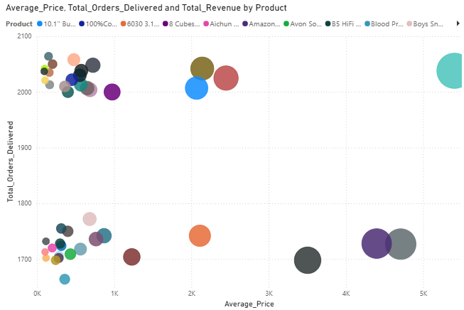

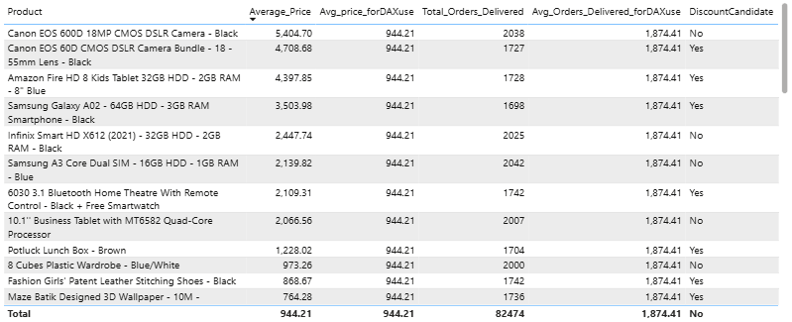

Insights / Analysis
Based on the benchmark criteria, the following products were identified as Discount Candidates (Yes):
- Canon EOS 60D CMOS DSLR Camera Bundle – 18–55mm Lens (Black)
  - Avg Price: ₹4,708.68
  - Orders: 1,727
- Amazon Fire HD 8 Kids Tablet (32GB, 2GB RAM – Blue)
  - Avg Price: ₹4,397.85
  - Orders: 1,728
- Samsung Galaxy A02 (64GB, 3GB RAM – Black)
  - Avg Price: ₹3,503.98
  - Orders: 1,698
- 6030 3.1 Bluetooth Home Theatre with Remote Control (Black + Free Smartwatch)
  - Avg Price: ₹2,109.31
  - Orders: 1,742
- Potluck Lunch Box – Brown
  - Avg Price: ₹1,228.02
  - Orders: 1,704
These products are priced significantly above the portfolio average yet generate below-average order volumes, indicating potential price resistance.
The scatter plot confirms this pattern visually, as these products cluster in the high-price, lower-demand region.
Revenue contribution was reviewed qualitatively to ensure that high-impact revenue drivers were not indiscriminately included in discount recommendations. This ensured that premium, strategically important products were protected from unnecessary margin erosion.

Recommendations

(a) Targeted Promotional Discounts
Offer limited-time price reductions for the identified products to stimulate demand and improve order volume.

(b) Bundling Strategies
Bundle premium underperforming products (e.g., DSLR bundle, Home Theatre system) with accessories to enhance perceived value rather than implementing heavy price cuts.

(c) Loyalty-Based Incentives
Provide exclusive offers to repeat customers to encourage trial of higher-priced products.

(d) Event-Based Promotions
Use seasonal campaigns or festival promotions instead of permanent markdowns to preserve brand positioning.

Conclusion
Using structured price and demand benchmarks supported by scatter plot validation, several high-priced, low-demand products were identified as suitable candidates for targeted discount strategies.

Ques8. Come up with a loyalty program to benefit the company’s customers. From the available lot of customers come up with strategies to bucket them and provide benefits under different loyalty programs.

Objective
The objective is to design a structured loyalty program by segmenting customers based on their engagement level and revenue contribution, so that targeted benefits can be provided to maximize retention and long-term profitability.

Approach
Since frequency is constant (1 order per customer), RM (Recency–Monetary) segmentation was applied:
- Recency: Days since last purchase (calculated using max order date reference).
- Monetary: Total revenue generated per customer.
- Customers were bucketed into recency bands (≤1 year, 1–3 years, 3–5 years, >5 years).
- Based on recency and revenue bands, loyalty segments were created:
  - Platinum
  - Gold
  - Silver
  - Retain – Priority
  - Win Back – High Value
  - Dormant
Visualizations used:
- Bar chart: Total customers by loyalty segment
- Table: Total customers, total revenue, revenue contribution %, average recency

DAX Used
Recency_Days = DATEDIFF(ORDERS_CLEANED[OrderDate],CALCULATE(MAX(ORDERS_CLEANED[OrderDate]),ALL(ORDERS_CLEANED)),DAY)

Monetary_Band = SWITCH(TRUE(),ORDERS_CLEANED[SalePrice]<500, "Low Value", ORDERS_CLEANED[SalePrice]<1500, "Medium Value", "High Value")

Recency_Band = SWITCH(TRUE(),ORDERS_CLEANED[Recency_Days]<=365, "Active",ORDERS_CLEANED[Recency_Days]<=1095,"Warm",ORDERS_CLEANED[Recency_Days]<=1825,"At Risk","Lost")

Loyalty_Segment_ = SWITCH(TRUE(), ORDERS_CLEANED[Recency_Band]="Active" && ORDERS_CLEANED[Monetary_Band]="High Value", "Platinum", ORDERS_CLEANED[Recency_Band]="Active" && ORDERS_CLEANED[Monetary_Band]="Medium Value", "Gold", ORDERS_CLEANED[Recency_Band]="Active" && ORDERS_CLEANED[Monetary_Band]="Low Value", "Silver", ORDERS_CLEANED[Recency_Band]="At Risk" && ORDERS_CLEANED[Monetary_Band]="High Value", "Retain- Priority", ORDERS_CLEANED[Recency_Band]="Lost" && ORDERS_CLEANED[Monetary_Band]="High Value", "Win Back- High Value", "Dormant")

Average_recency_days = AVERAGE(ORDERS_CLEANED[Recency_Days])

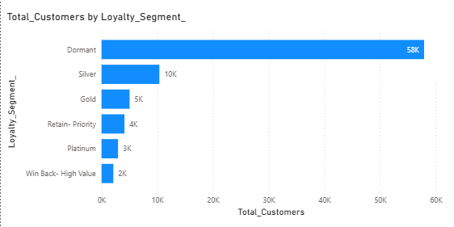

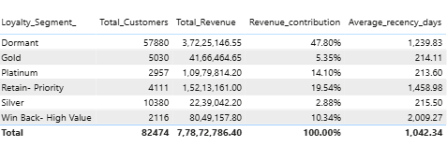

Key Findings
- Dormant customers form the largest group (~58K) and contribute ~48% of total revenue, but have high recency (~1239 days), indicating inactivity.
- Retain–Priority and Win Back – High Value segments together contribute ~30% of revenue but are highly inactive.
- Platinum customers are recent and contribute ~14% of total revenue despite being a smaller base.
- Silver and Gold segments are recent but lower revenue contributors, indicating growth potential.

Business Recommendations
- Platinum: Offer VIP benefits, exclusive access, and priority support to protect high-value revenue.
- Gold: Provide reward points and upgrade incentives to move them toward Platinum.
- Silver: Encourage repeat purchase via cashback and bundle offers.
- Retain – Priority: Run targeted re-engagement campaigns to prevent revenue loss.
- Win Back – High Value: Use aggressive comeback offers to reactivate high historical contributors.
- Dormant: Implement automated mass reactivation campaigns to capture incremental revenue.

Conclusion
The RM-based segmentation reveals that a large portion of revenue is concentrated among inactive customers. A tier-based loyalty program focused on retention, reactivation, and value enhancement will help stabilize revenue, improve customer lifetime value, and optimize marketing spend.

Q9: Using the DAX functions Calculate and a row iteration DAX function calculate the total sales for the Product Category “Fashion” and delivery type “Shipped from Abroad”. What are the other types of DAX functions you have used in the project?

Objective
To calculate the total sales for:
- Product Category: Fashion
- Delivery Type: Shipped from Abroad
- Considering only Delivered orders
The calculation must use:
- CALCULATE() (to modify filter context)
- A row iteration function (such as SUMX())

DAX Implementation
The following DAX measure was created:
Total_Sales_Fashion_Abroad = CALCULATE(SUMX(ORDERS_CLEANED,ORDERS_CLEANED[UnitPrice]*ORDERS_CLEANED[OrderQuantity]+ORDERS_CLEANED[ShippingFee]),ORDERS_CLEANED[ProductCategory]="Fashion",ORDERS_CLEANED[DeliveryType]="Shipped from Abroad", ORDERS_CLEANED[Status]="Delivered")

Explanation of the Logic
- SUMX() is used as a row iterator to compute sales at the transaction level by multiplying UnitPrice × OrderQuantity and adding ShippingFee.
- CALCULATE() modifies the filter context to include only:
  - Product Category = Fashion
  - Delivery Type = Shipped from Abroad
  - Status = Delivered
This ensures that only relevant transactions are aggregated

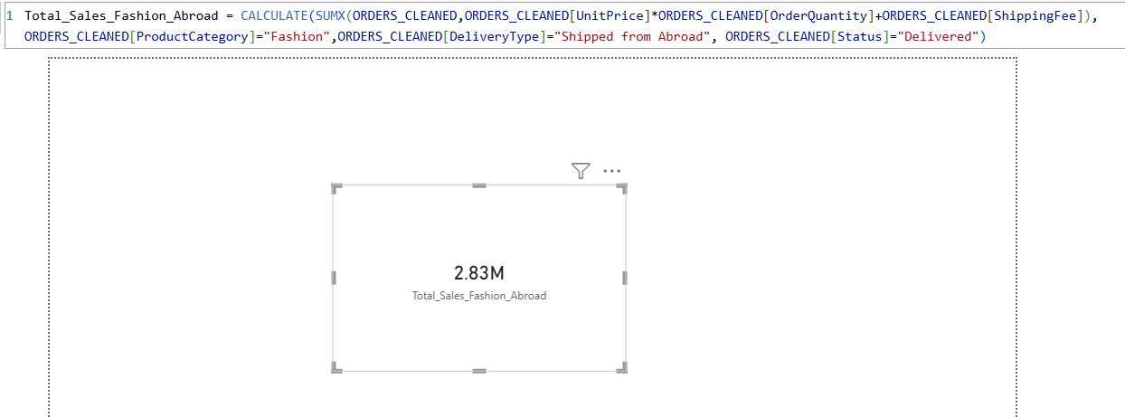

Result
The total sales for Fashion products shipped from abroad (Delivered orders only) equals:
2.83 Million

Other Types of DAX Functions Used in the Project
Throughout the project, the following categories of DAX functions were used:

Aggregation Functions
- SUM()
- AVERAGE()
- DISTINCTCOUNT()

Filter Functions
- CALCULATE()
- FILTER()
- ALL()
- VALUES()

Iterator Functions
- SUMX()
- AVERAGEX()
- PERCENTILEX.INC()

Logical Functions
- IF()
- SWITCH()
- TRUE()

Date & Time Functions
- DATEDIFF()
- MAX()

Conclusion
The required total sales were calculated successfully using both CALCULATE() and a row iteration function (SUMX()), demonstrating understanding of filter context and row context in DAX.

Ques 10. Wait Times Correlated with Demographics and Care: Explore how average wait times vary across different product categories to optimize scheduling and staffing.

Objective
To analyze how average wait times vary across different product categories in order to identify potential operational inefficiencies and support scheduling and staffing optimization.

DAX Created
Wait Time (Calculated Column)
Wait_Time = DATEDIFF(ORDERS_CLEANED[OrderDate],ORDERS_CLEANED[DeliveryDate],DAY)

Measure:
Avg_Wait_Time = CALCULATE(AVERAGE(ORDERS_CLEANED[Wait_Time]),ORDERS_CLEANED[Status]="Delivered")

Visualizations Used
- KPI Card – Overall Average Wait Time
- Bar Chart – Average Wait Time by Product Category
- Supporting Table – Product Category, Average Wait Time, Total Orders Delivered

Key Findings
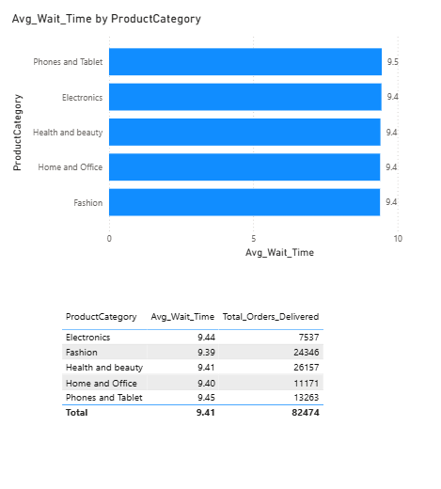
- The overall average wait time across all delivered orders is 9.41 days.
- The highest average wait time is observed in Phones and Tablet (9.45 days).
- The lowest average wait time is observed in Fashion (9.39 days).
- The total variation across categories is only 0.06 days, which is operationally negligible.
- High-volume categories such as Health and Beauty (26,157 orders) and Fashion (24,346 orders) do not show elevated wait times.

Business Interpretation
The minimal variation in average wait time across product categories indicates that fulfillment operations are consistently managed across all categories. There is no evidence of category-specific bottlenecks affecting delivery performance.
The data suggests that scheduling and staffing allocation are currently balanced and effectively distributed.

Recommendations
- Maintain the current staffing and scheduling structure.
- Continue periodic monitoring of high-volume categories to prevent future capacity constraints.
- For deeper operational insights, further analysis could be conducted by region, warehouse, or delivery partner.

Ques 11. Explore if there is any relationship between the Delivery type and waiting time between ordering and receiving an item.

Objective
To explore whether there is a relationship between delivery type and the waiting time between placing an order and receiving the item.

DAX Used
Wait Time (Calculated Column)
Wait_Time_Days =
DATEDIFF(
ORDERS_CLEANED[OrderDate],
ORDERS_CLEANED[DeliveryDate],
DAY
)
Average Wait Time (Delivered Orders Only)
Average_Wait_Time =
CALCULATE(
AVERAGE(ORDERS_CLEANED[Wait_Time_Days]),
ORDERS_CLEANED[Status] = "Delivered"
)
Minimum Wait Time
Min_Wait_Time =
CALCULATE(
MIN(ORDERS_CLEANED[Wait_Time_Days]),
ORDERS_CLEANED[Status] = "Delivered"
)
Maximum Wait Time
Max_Wait_Time =
CALCULATE(
MAX(ORDERS_CLEANED[Wait_Time_Days]),
ORDERS_CLEANED[Status] = "Delivered"
)
Median Wait Time
Median_Wait_Time =
CALCULATE(
MEDIAN(ORDERS_CLEANED[Wait_Time_Days]),
ORDERS_CLEANED[Status] = "Delivered"
)
All measures were restricted to delivered orders to ensure operational accuracy.

Visualizations Used
- Bar Chart – Average Wait Time by Delivery Type
- Supporting Table – Delivery Type with Average, Median, Minimum, Maximum Wait Time and Total Orders Delivered
- KPI Card – Overall Average Wait Time

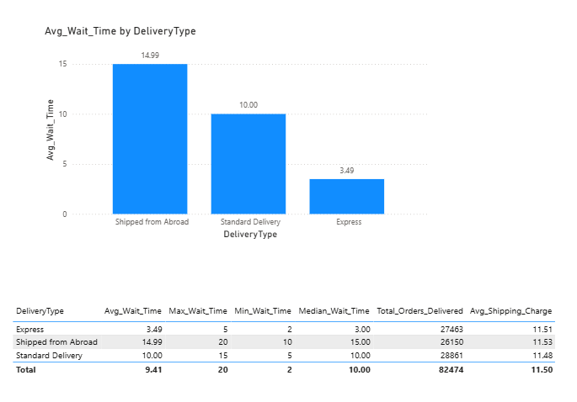

Key Findings
Overall average wait time is 9.41 days.

By Delivery Type:
Express
- Average: 3.49 days
- Median: 3.00 days
- Min: 2 days
- Max: 5 days
- Orders: 27,463
Standard Delivery
- Average: 10.00 days
- Median: 10.00 days
- Min: 5 days
- Max: 15 days
- Orders: 28,861
Shipped from Abroad
- Average: 14.99 days
- Median: 15.00 days
- Min: 10 days
- Max: 20 days
- Orders: 26,150

Business Interpretation
There is a clear and strong relationship between delivery type and waiting time.
- Express delivery has the lowest waiting time and a very tight range (2–5 days), indicating high operational efficiency.
- Standard delivery takes approximately three times longer than Express and shows a moderate range (5–15 days).
- Shipped from Abroad has the highest waiting time (10–20 days), reflecting international logistics complexity.
The similarity between mean and median values across all delivery types indicates that the distributions are stable and not heavily skewed by outliers.
Since order volumes are relatively similar across all three delivery types, the observed differences are operationally significant and not caused by small sample sizes.

Recommendations
- Promote Express delivery for customers prioritizing faster service.
- Improve logistics efficiency for international shipments where feasible.
- Clearly communicate expected waiting times to customers based on delivery type to manage expectations.

Conclusion
Delivery type is a key determinant of waiting time.
Customers choosing Express experience significantly faster fulfillment, while international shipments result in substantially longer waiting periods. The strong separation between delivery types confirms a direct relationship between delivery mode and fulfillment duration.

Ques 12. Is there any relationship between shipping charges and product type?
Objective
The objective is to analyze whether there exists a relationship between shipping charges and product type. Additionally, an extended analysis was performed to examine whether shipping charges vary with average order value across different product categories.

DAX Used
Avg_Order_Cost = CALCULATE(AVERAGEX(ORDERS_CLEANED,ORDERS_CLEANED[UnitPrice]*ORDERS_CLEANED[OrderQuantity]),ORDERS_CLEANED[Status]="Delivered")

Avg_Shipping_Charge = CALCULATE(AVERAGE(ORDERS_CLEANED[ShippingFee]),ORDERS_CLEANED[Status]="Delivered")

Visualizations Created
Bar Chart – Average Shipping Charge by Delivery Type
Scatter Plot – Avg Order Cost vs Avg Shipping Charge by Product Category
Card Visual – Overall Average Shipping Charge
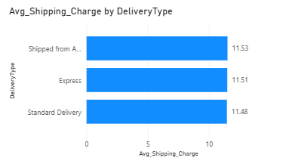

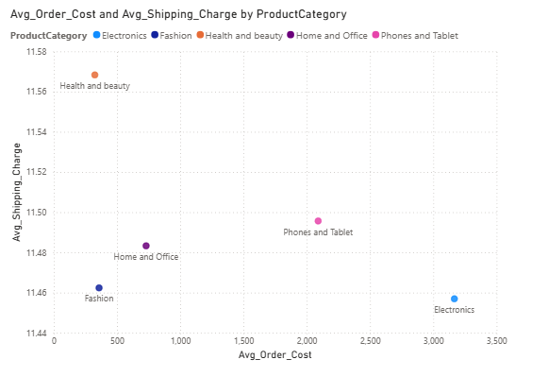

Observations
- The overall average shipping charge is 11.50.
- Across delivery types, shipping charges vary slightly (11.48–11.53 range).
- In the scatter plot, product categories show significant variation in average order cost (approximately 400 to 3300+).
- However, shipping charges remain almost constant across all categories (11.45–11.56 range).
For example:
- Electronics has the highest average order cost but one of the lowest average shipping charges.
- Health & Beauty has low average order cost but relatively higher shipping charge.
There is no clear upward or downward trend between order value and shipping charge.

Conclusion
There is no strong relationship between shipping charges and product type. Shipping charges appear largely uniform across categories and do not increase proportionally with product value.
This suggests that the company likely follows a near flat-rate shipping model, possibly driven more by delivery type rather than product price.
From a business perspective, this pricing structure simplifies logistics but may not reflect cost-based differentiation across product categories.

Ques 13. Come up with strategies to decrease the low rating orders after analyzing different factors like waiting time, shipping type, unit price, etc.

Objective
The objective of this analysis is to identify the key drivers behind low-rated orders (Rating ≤ 2 on a 1–5 scale) and recommend actionable strategies to reduce customer dissatisfaction.
The analysis was conducted only on Delivered orders to ensure consistency and relevance.

DAX Used
Low_Rating_Orders = CALCULATE(COUNT(ORDERS_CLEANED[OrderID]),ORDERS_CLEANED[Rating]<=2,ORDERS_CLEANED[Status]="Delivered")
Avg_Wait_Time_for_Low_Rated = CALCULATE(AVERAGE(ORDERS_CLEANED[Wait_Time]),ORDERS_CLEANED[Rating]<=2,ORDERS_CLEANED[Status]="Delivered")
Avg_Wait_Time_for_High_Rated = CALCULATE(AVERAGE(ORDERS_CLEANED[Wait_Time]),ORDERS_CLEANED[Rating]>2,ORDERS_CLEANED[Status]="Delivered")
UnitPrice_Band = SWITCH(TRUE(),ORDERS_CLEANED[UnitPrice]<=200, "Low", ORDERS_CLEANED[UnitPrice]>200 && ORDERS_CLEANED[UnitPrice]<=800, "Medium",ORDERS_CLEANED[UnitPrice]>800,"High")

Visualizations Created
- Card Visual – Total Low Rated Orders and Low Rating %
- Bar Chart – Low Rating % by Delivery Type
- Bar Chart – Low Rating % by Product Category
- Table – Delivery Type with Low Rating %, Avg Wait (Low vs High Rated)
- Table – Product Category with Low Rating %, Avg Wait (Low vs High Rated)
- Table – Unit Price Band with Low Rating %, Avg Wait (Low vs High Rated)

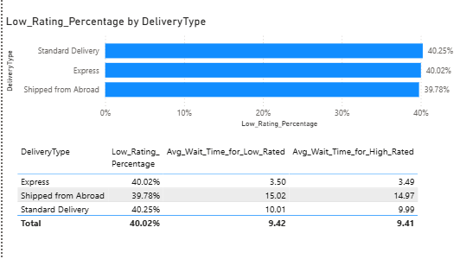

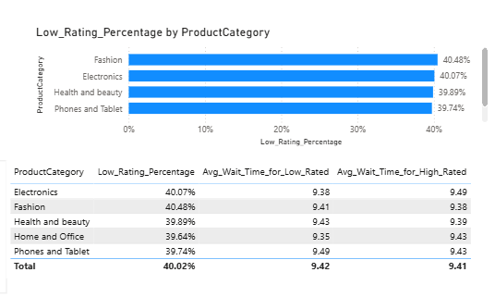

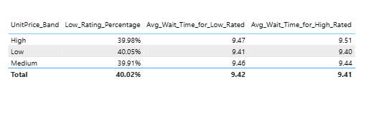

Key Findings

Overall Situation
- Total Low Rated Orders ≈ 33K
- Low Rating Percentage ≈ 40%
- Average Rating ≈ 3
This indicates a widespread dissatisfaction issue.

Delivery Type Analysis
Low rating percentage by delivery type:
- Standard Delivery → 40.25%
- Express → 40.02%
- Shipped from Abroad → 39.78%
The variation is negligible (<0.5%).
Conclusion: Delivery type is not a significant driver of low ratings.

Waiting Time Analysis
Across delivery types and product categories, the difference in average wait time between low-rated and high-rated orders is minimal (≈ 0.01–0.05 days).
Example:
- Express: 3.50 (Low Rated) vs 3.49 (High Rated)
- Standard: 10.01 vs 9.99
- Shipped from Abroad: 15.02 vs 14.97
Conclusion: Waiting time does not significantly influence low ratings.

Product Category Analysis
Low rating percentage across categories:
- Fashion → 40.48%
- Electronics → 40.07%
- Health & Beauty → 39.89%
- Phones & Tablet → 39.74%
Variation is minimal.
Conclusion: Product category is not a primary cause.

Unit Price Band Analysis
Low rating percentage across price bands:
- Low → 40.05%
- Medium → 39.91%
- High → 39.98%
No significant variation observed.
Conclusion: Product price level does not strongly influence dissatisfaction.

Interpretation
Since low rating percentage remains consistently around 40% across:
- Delivery Type
- Product Category
- Waiting Time
- Unit Price Bands
The dissatisfaction appears to be systemic rather than segment-specific.
This suggests the root cause is likely not related to logistics, pricing, or specific product categories.
The issue may be associated with:
- Product quality inconsistencies
- Seller-level performance differences
- Mismatch between product description and actual product
- Packaging damage
- Overall customer experience issues

Recommended Strategies to Decrease Low Ratings
- Strengthen Vendor Quality Control
Implement stricter onboarding and performance monitoring for sellers. Flag sellers with consistently low ratings.
- Improve Product Listing Accuracy
Ensure product images, descriptions, and specifications match the actual product delivered.
- Post-Delivery Intervention System
Trigger automated customer support follow-ups for ratings ≤ 2 to resolve issues before dissatisfaction spreads.
- Seller-Level Performance Dashboard
Track Low Rating % at the seller level and penalize consistently underperforming vendors.
- Improve Packaging Standards
Introduce standardized packaging requirements to reduce damage-related complaints.
- Customer Feedback Analysis
If textual reviews are available, perform sentiment analysis to identify recurring complaints (e.g., size issues, quality mismatch, damaged items).

Conclusion
The analysis indicates that low ratings are not significantly driven by delivery type, waiting time, product category, or unit price. Dissatisfaction is evenly distributed across segments, pointing to a broader systemic issue.
Therefore, strategic focus should shift from logistics optimization to quality assurance, vendor performance management, and customer experience enhancement to meaningfully reduce low-rated orders.

Ques 14. Using the time intelligence DAX function, create a table to compare each month’s sales with the previous year’s same month’s total sales. So there will be four columns in the output year, month, total sales, previous_years_sales.

Objective
The objective is to compare each month’s total sales with the total sales of the same month in the previous year using a Time Intelligence DAX function.
This helps in identifying year-over-year (YoY) performance trends and seasonal growth patterns.

DAX Used
Previous_Year_Sales = CALCULATE([Total_Revenue],SAMEPERIODLASTYEAR('Calendar'[Date]))

Visual Created
A Table visual was created with the following columns:
- Date[Year]
- Date[Month Name]
- Total_Revenue
- Previous_Year_Sales
Month was sorted using Month Number to maintain chronological order.

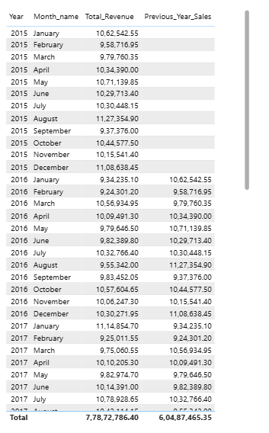

Key Observations
- For the first year in the dataset (2015), Previous Year Sales is blank, which is expected as there is no prior year data available.
- For 2016 January:
  - Total Revenue (2016 Jan) is compared with
  - Revenue of 2015 January
- Similarly, for 2017 January:
  - Revenue is correctly compared with 2016 January.
This confirms correct time shifting behavior.

Business Interpretation
This table enables:
- Month-over-month seasonal comparison across years
- Detection of growth or decline patterns
- Identification of strong and weak months
- Strategic planning based on historical monthly performance
For example: If a month’s Total Revenue is consistently lower than its Previous Year Sales, it indicates negative YoY growth for that month.

6. Conclusion
Using CALCULATE and SAMEPERIODLASTYEAR, a dynamic year-over-year comparison table was successfully created.
The implementation is correct, logically consistent, and suitable for analyzing seasonal and annual sales trends.

Ques 15. What do you understand by PowerBI gateway? What are its use cases?

Power BI Gateway is a bridge that allows secure data transfer between on-premises data sources and Power BI Service in the cloud. It enables Power BI to access and refresh data stored locally (such as SQL Server, Excel files, or other enterprise databases) without exposing the internal network.
Use Cases:
- Enabling scheduled refresh for on-premises databases.
- Supporting live connections to local SQL Server or Analysis Services.
- Maintaining secure and encrypted data transfer between local servers and Power BI Service.
- Allowing multiple users to access centrally managed data sources through the Enterprise Gateway.
In short, Power BI Gateway ensures secure connectivity and real-time or scheduled data updates from on-premise systems to cloud-based Power BI reports.

Question 16: How would you approach this problem, if the objective and subjective questions weren't given?

1. Start With Business Understanding
Before touching the data, I would try to understand:
- What kind of company is this?
- What are the possible business goals? (Revenue growth, retention, cost reduction, customer satisfaction, etc.)
- What decisions might stakeholders want to make?
If no objective is provided, I would assume the general business goal is to improve revenue, profitability, and customer retention.

2. Perform Initial Data Exploration (EDA)
I would begin with exploratory analysis:
- Understand dataset structure (tables, relationships, date table, key columns)
- Check data quality (missing values, duplicates, anomalies)
- Identify key measures: revenue, orders, customers, shipping cost, ratings, wait time
Then I would ask:
- How does revenue behave over time?
- Which categories contribute most?
- What is customer distribution?
- Are there patterns in ratings, shipping, or wait time?
This stage helps generate natural business questions from the data itself.

3. Identify Core Business Dimensions
Typically, in an e-commerce dataset, I would analyze across:
- Time (Year, Month trends)
- Product (Category performance)
- Customer (Segmentation, loyalty, recency)
- Delivery (Shipping type, wait time impact)
- Experience (Ratings vs service metrics)
From here, patterns usually emerge — for example:
- High revenue but high churn
- High wait time leading to low ratings
- Certain categories underperforming

4. Form Hypotheses
Instead of answering predefined questions, I would create my own hypotheses:
- Does wait time impact customer ratings?
- Do high-value customers become inactive over time?
- Are certain delivery types inefficient?
- Does shipping cost affect order value?
Then I would validate these hypotheses using visualizations and measures.

5. Move Toward Actionable Insights
After analysis, I would convert insights into business recommendations:
- Improve logistics where wait time is high
- Introduce loyalty programs for high-value customers
- Optimize pricing or shipping strategy
- Focus marketing on high-performing categories
The key is not just analyzing, but converting insights into decisions.

6. Final Step: Tell a Business Story
Even without predefined questions, I would structure findings into a narrative:
- Current performance overview
- Key risks
- Growth opportunities
- Strategic recommendations
Because in real-world analytics, stakeholders rarely give perfectly framed questions. A good analyst identifies problems, validates them with data, and proposes solutions.

In short, without given objectives, I would:
Explore → Identify patterns → Form hypotheses → Validate → Recommend actions.
That is how I would approach the problem in a real business scenario.

